**Nama : Bayu Prasetya Adji Sugiyarto**

**NIM : A11.2019.11688**

**Pertemuan : 4**

**Kelompok : A11.4304**

**Droid Cafe**

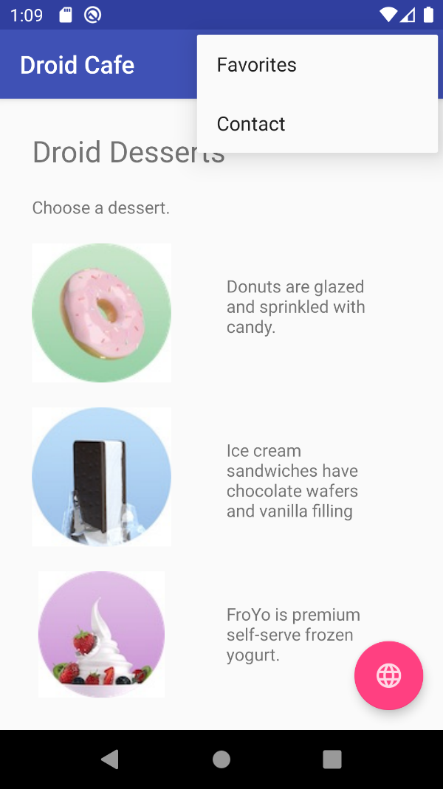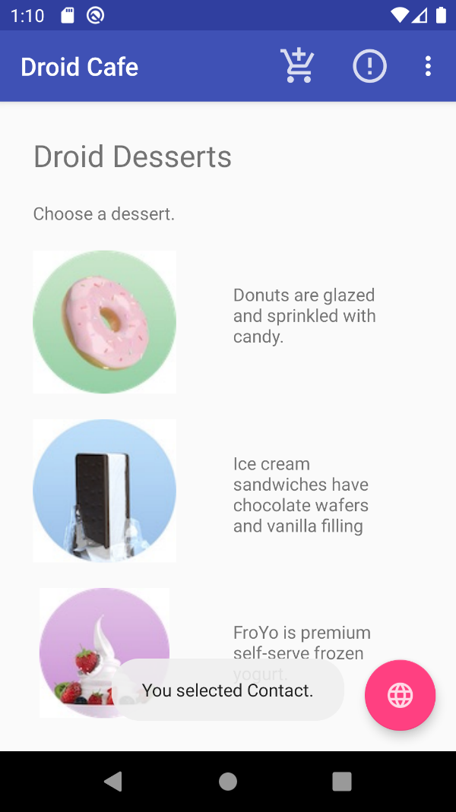

**Mainactivity.Java**  
**package** com.example.android.droidcafe;  
  
**import** android.content.Intent;  
**import** android.net.Uri;  
**import** android.os.Bundle;  
**import** android.support.design.widget.FloatingActionButton;  
**import** android.support.v7.app.AppCompatActivity;  
**import** android.support.v7.widget.Toolbar;  
**import** android.view.Menu;  
**import** android.view.MenuItem;  
**import** android.view.View;  
**import** android.widget.Toast;  
  
**public class** MainActivity **extends** AppCompatActivity {  
  
  
 @Override  
 **protected void** onCreate(Bundle savedInstanceState) {  
 **super**.onCreate(savedInstanceState);  
 setContentView(R.layout.***activity_main***);  
 Toolbar toolbar = (Toolbar) findViewById(R.id.***toolbar***);  
 setSupportActionBar(toolbar);  
  
 FloatingActionButton fab = (FloatingActionButton) findViewById(R.id.***fab***);  
 fab.setOnClickListener(**new** View.OnClickListener() {  
 @Override  
 **public void** onClick(View view) {  
 displayMap();  
 }  
 });  
 }  
  
 @Override  
 **public boolean** onCreateOptionsMenu(Menu menu) {  
 getMenuInflater().inflate(R.menu.***menu_main***, menu);  
 **return true**;  
 }  
  
 @Override  
 **public boolean** onOptionsItemSelected(MenuItem item) {  
 **switch** (item.getItemId()) {  
 **case** R.id.***action_order***:  
 displayToast(getString(R.string.***action_order_message***));  
 **return true**;  
 **case** R.id.***action_status***:  
 displayToast(getString(R.string.***action_status_message***));  
 **return true**;  
 **case** R.id.***action_favorites***:  
 displayToast(getString(R.string.***action_favorites_message***));  
 **return true**;  
 **case** R.id.***action_contact***:  
 displayToast(getString(R.string.***action_contact_message***));  
 **return true**;  
 **default**:  
 *// Do nothing* }  
 **return super**.onOptionsItemSelected(item);  
 }  
  
 **public void** showDonutOrder(View view) {  
 showFoodOrder(getString(R.string.***donut_order_message***));  
 }  
  
 **public void** showIceCreamOrder(View view) {  
 showFoodOrder(getString(R.string.***ice_cream_order_message***));  
 }  
  
 **public void** showFroyoOrder(View view) {  
 showFoodOrder(getString(R.string.***froyo_order_message***));  
 }  
  
 **public void** showFoodOrder(String message) {  
 displayToast(message);  
 Intent intent = **new** Intent(**this**, OrderActivity.**class**);  
 startActivity(intent);  
 }  
  
 **public void** displayToast(String message) {  
 Toast.*makeText*(getApplicationContext(), message, Toast.***LENGTH_SHORT***).show();  
 }  
  
 **public void** displayMap() {  
 Intent intent = **new** Intent();  
 intent.setAction(Intent.***ACTION_VIEW***);  
 String data = getString(R.string.***google_mtv_coord_zoom12***);  
 intent.setData(Uri.*parse*(data));  
 **if** (intent.resolveActivity(getPackageManager()) != **null**) {  
 startActivity(intent);  
 }  
 }  
}

**activity_main.xml**

*<?***xml version="1.0" encoding="utf-8"***?>*<**android.support.design.widget.CoordinatorLayout xmlns:android="http://schemas.android.com/apk/res/android"  
 xmlns:app="http://schemas.android.com/apk/res-auto"  
 xmlns:tools="http://schemas.android.com/tools"  
 android:layout_width="match_parent"  
 android:layout_height="match_parent"  
 android:fitsSystemWindows="true"  
 tools:context="com.example.android.droidcafe.MainActivity"**>  
  
 <**android.support.design.widget.AppBarLayout  
 android:layout_width="match_parent"  
 android:layout_height="wrap_content"  
 android:theme="@style/AppTheme.AppBarOverlay"**>  
  
 <**android.support.v7.widget.Toolbar  
 android:id="@+id/toolbar"  
 android:layout_width="match_parent"  
 android:layout_height="?attr/actionBarSize"  
 android:background="?attr/colorPrimary"  
 app:popupTheme="@style/AppTheme.PopupOverlay"** />  
  
 </**android.support.design.widget.AppBarLayout**>  
  
 <**include layout="@layout/content_main"** />  
  
 <**android.support.design.widget.FloatingActionButton  
 android:id="@+id/fab"  
 android:layout_width="wrap_content"  
 android:layout_height="wrap_content"  
 android:layout_gravity="bottom|end"  
 android:layout_margin="@dimen/fab_margin"  
 app:srcCompat="@drawable/ic_map"** />  
  
</**android.support.design.widget.CoordinatorLayout**>

**Content_main.xml**

*<?***xml version="1.0" encoding="utf-8"***?>*<**RelativeLayout xmlns:android="http://schemas.android.com/apk/res/android"  
 xmlns:app="http://schemas.android.com/apk/res-auto"  
 xmlns:tools="http://schemas.android.com/tools"  
 android:id="@+id/content_main"  
 android:layout_width="match_parent"  
 android:layout_height="match_parent"  
 android:paddingBottom="@dimen/activity_vertical_margin"  
 android:paddingLeft="@dimen/activity_horizontal_margin"  
 android:paddingRight="@dimen/activity_horizontal_margin"  
 android:paddingTop="@dimen/activity_vertical_margin"  
 app:layout_behavior="@string/appbar_scrolling_view_behavior"  
 tools:context="com.example.android.droidcafe.MainActivity"  
 tools:showIn="@layout/activity_main"**>  
  
 <**TextView  
 android:id="@+id/textintro"  
 android:layout_width="wrap_content"  
 android:layout_height="wrap_content"  
 android:textSize="@dimen/text_heading"  
 android:padding="@dimen/padding_regular"  
 android:text="@string/intro_text"** />  
  
 <**TextView  
 android:layout_width="wrap_content"  
 android:layout_height="wrap_content"  
 android:padding="@dimen/padding_regular"  
 android:id="@+id/choose_dessert"  
 android:layout_below="@id/textintro"  
 android:text="@string/choose_a_dessert"**/>  
  
 <**ImageView  
 android:layout_width="wrap_content"  
 android:layout_height="wrap_content"  
 android:padding="@dimen/padding_regular"  
 android:id="@+id/donut"  
 android:layout_below="@id/choose_dessert"  
 android:contentDescription="@string/donuts"  
 android:src="@drawable/donut_circle"  
 android:onClick="showDonutOrder"**/>  
  
 <**TextView  
 android:layout_width="wrap_content"  
 android:layout_height="wrap_content"  
 android:padding="@dimen/padding_wide"  
 android:layout_below="@id/choose_dessert"  
 android:layout_toRightOf="@id/donut"  
 android:text="@string/donuts"**/>  
  
 <**ImageView  
 android:layout_width="wrap_content"  
 android:layout_height="wrap_content"  
 android:padding="@dimen/padding_regular"  
 android:id="@+id/ice_cream"  
 android:layout_below="@id/donut"  
 android:contentDescription="@string/ice_cream_sandwiches"  
 android:src="@drawable/icecream_circle"  
 android:onClick="showIceCreamOrder"**/>  
  
 <**TextView  
 android:layout_width="wrap_content"  
 android:layout_height="wrap_content"  
 android:padding="@dimen/padding_wide"  
 android:layout_below="@id/donut"  
 android:layout_toRightOf="@id/ice_cream"  
 android:text="@string/ice_cream_sandwiches"**/>  
  
 <**ImageView  
 android:layout_width="wrap_content"  
 android:layout_height="wrap_content"  
 android:padding="@dimen/padding_regular"  
 android:id="@+id/froyo"  
 android:layout_below="@id/ice_cream"  
 android:contentDescription="@string/froyo"  
 android:src="@drawable/froyo_circle"  
 android:onClick="showFroyoOrder"**/>  
  
 <**TextView  
 android:layout_width="wrap_content"  
 android:layout_height="wrap_content"  
 android:padding="@dimen/padding_wide"  
 android:layout_below="@id/ice_cream"  
 android:layout_toRightOf="@id/froyo"  
 android:text="@string/froyo"**/>  
  
</**RelativeLayout**>

**Menu_main.xml**  
<**menu xmlns:android="http://schemas.android.com/apk/res/android"  
 xmlns:app="http://schemas.android.com/apk/res-auto"  
 xmlns:tools="http://schemas.android.com/tools"  
 tools:context="com.example.android.droidcafe.MainActivity"**>  
 <**item  
 android:id="@+id/action_contact"  
 android:orderInCategory="100"  
 android:title="@string/action_contact"  
 app:showAsAction="never"** />  
 <**item  
 android:id="@+id/action_order"  
 android:orderInCategory="10"  
 android:title="@string/action_order"  
 android:icon="@drawable/ic_order_white"  
 app:showAsAction="always"** />  
 <**item  
 android:id="@+id/action_status"  
 android:orderInCategory="20"  
 android:title="@string/action_status"  
 android:icon="@drawable/ic_status_white"  
 app:showAsAction="always"** />  
 <**item  
 android:id="@+id/action_favorites"  
 android:orderInCategory="40"  
 android:title="@string/action_favorites"  
 android:icon="@drawable/ic_favorites_white"  
 app:showAsAction="ifRoom"** />  
</**menu**>

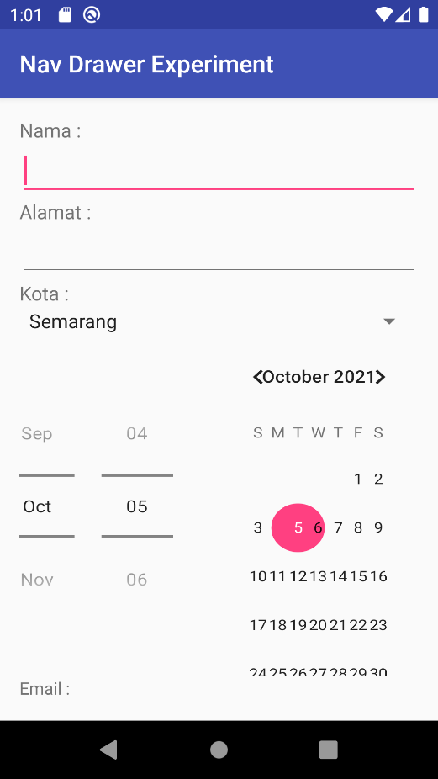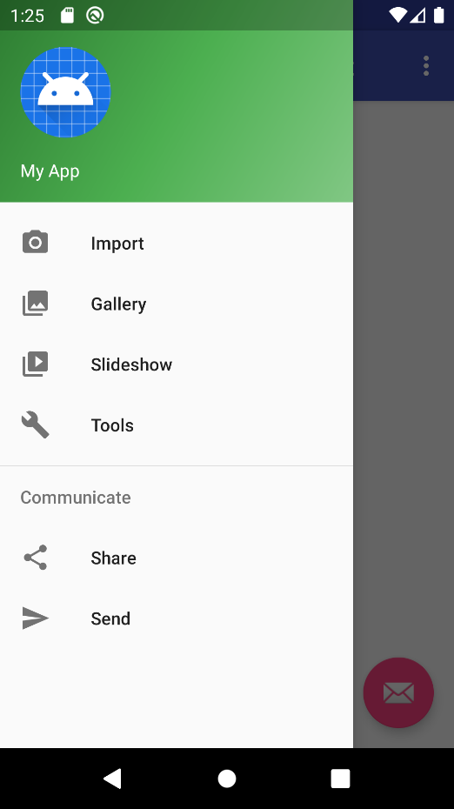**NavDrawerExperiment**

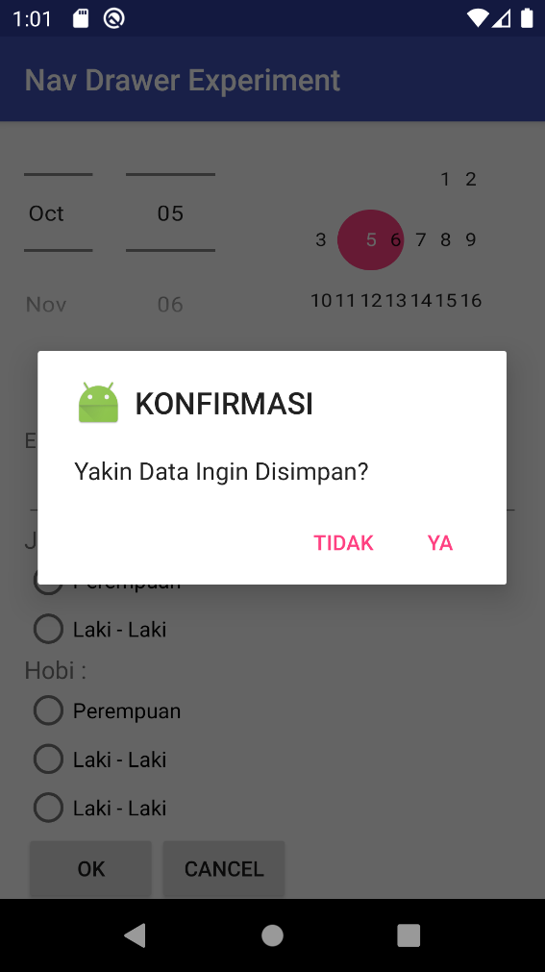

**Mainactivity.java**

**package** com.example.android.navdrawerexperiment;  
  
**import** android.content.Intent;  
**import** android.os.Bundle;  
**import** android.support.design.widget.FloatingActionButton;  
**import** android.support.design.widget.Snackbar;  
**import** android.view.View;  
**import** android.support.design.widget.NavigationView;  
**import** android.support.v4.view.GravityCompat;  
**import** android.support.v4.widget.DrawerLayout;  
**import** android.support.v7.app.ActionBarDrawerToggle;  
**import** android.support.v7.app.AppCompatActivity;  
**import** android.support.v7.widget.Toolbar;  
**import** android.view.Menu;  
**import** android.view.MenuItem;  
**import** android.widget.Toast;  
  
  
**public class** MainActivity **extends** AppCompatActivity  
 **implements** NavigationView.OnNavigationItemSelectedListener {  
  
 @Override  
 **protected void** onCreate(Bundle savedInstanceState) {  
 **super**.onCreate(savedInstanceState);  
 setContentView(R.layout.***activity_main***);  
 Toolbar toolbar = (Toolbar) findViewById(R.id.***toolbar***);  
 setSupportActionBar(toolbar);  
  
 FloatingActionButton fab = (FloatingActionButton) findViewById(R.id.***fab***);  
 **if** (fab != **null**) {  
 fab.setOnClickListener(**new** View.OnClickListener() {  
 @Override  
 **public void** onClick(View view) {  
 Snackbar.*make*(view, **"Replace with your own action"**, Snackbar.***LENGTH_LONG***)  
 .setAction(**"Action"**, **null**).show();  
 }  
 });  
 }  
  
 DrawerLayout drawer = (DrawerLayout) findViewById(R.id.***drawer_layout***);  
 ActionBarDrawerToggle toggle = **new** ActionBarDrawerToggle(  
 **this**, drawer, toolbar, R.string.***navigation_drawer_open***,  
 R.string.***navigation_drawer_close***);  
 **if** (drawer != **null**) {  
 drawer.addDrawerListener(toggle);  
 }  
 toggle.syncState();  
  
 NavigationView navigationView = (NavigationView) findViewById(R.id.***nav_view***);  
 **if** (navigationView != **null**) {  
 navigationView.setNavigationItemSelectedListener(**this**);  
 }  
 }  
  
 @Override  
 **public void** onBackPressed() {  
 DrawerLayout drawer = (DrawerLayout) findViewById(R.id.***drawer_layout***);  
 **if** (drawer != **null**) {  
 **if** (drawer.isDrawerOpen(GravityCompat.***START***)) {  
 drawer.closeDrawer(GravityCompat.***START***);  
 } **else** {  
 **super**.onBackPressed();  
 }  
 }  
 }  
  
 @Override  
 **public boolean** onCreateOptionsMenu(Menu menu) {  
getMenuInflater().inflate(R.menu.***main***, menu);  
 **return true**;  
 }  
  
 @Override  
 **public boolean** onOptionsItemSelected(MenuItem item) {  
**int** id = item.getItemId();  
  
 *//noinspection SimplifiableIfStatement* **if** (id == R.id.***action_settings***) {  
 **return true**;  
 }  
  
 **return super**.onOptionsItemSelected(item);  
 }  
  
 @SuppressWarnings(**"StatementWithEmptyBody"**)  
 @Override  
 **public boolean** onNavigationItemSelected(MenuItem item) {  
 DrawerLayout drawer = (DrawerLayout) findViewById(R.id.***drawer_layout***);  
 *// Handle navigation view item clicks here.* **switch** (item.getItemId()) {  
 **case** R.id.***nav_camera***:  
 *// Handle the camera import action (for now display a toast).* drawer.closeDrawer(GravityCompat.***START***);  
 displayToast(getString(R.string.***chose_camera***));  
 **return true**;  
 **case** R.id.***nav_gallery***:  
 *// Handle the gallery action (for now display a toast).* drawer.closeDrawer(GravityCompat.***START***);  
 displayToast(getString(R.string.***chose_gallery***));  
 **return true**;  
 **case** R.id.***nav_slideshow***:  
 *// Handle the slideshow action (for now display a toast).* drawer.closeDrawer(GravityCompat.***START***);  
 Intent intentform = **new** Intent(MainActivity.**this**,form.**class**);  
 startActivity(intentform);  
 **return true**;  
 **case** R.id.***nav_manage***:  
 *// Handle the tools action (for now display a toast).* drawer.closeDrawer(GravityCompat.***START***);  
 displayToast(getString(R.string.***chose_tools***));  
 **return true**;  
 **case** R.id.***nav_share***:  
 *// Handle the share action (for now display a toast).* drawer.closeDrawer(GravityCompat.***START***);  
 displayToast(getString(R.string.***chose_share***));  
 **return true**;  
 **case** R.id.***nav_send***:  
 *// Handle the send action (for now display a toast).* drawer.closeDrawer(GravityCompat.***START***);  
 displayToast(getString(R.string.***chose_send***));  
 **return true**;  
 **default**:  
 **return false**;  
 }  
 }  
   
 **public void** displayToast(String message) {  
 Toast.*makeText*(getApplicationContext(), message, Toast.***LENGTH_SHORT***).show();  
 }  
}

**form.java**

**package** com.example.android.navdrawerexperiment;  
  
**import** android.content.DialogInterface;  
**import** android.support.v7.app.AlertDialog;  
**import** android.support.v7.app.AppCompatActivity;  
**import** android.os.Bundle;  
**import** android.view.View;  
**import** android.widget.Button;  
  
  
**public class** form **extends** AppCompatActivity {  
 **private** Button **Alert**;  
  
 @Override  
 **protected void** onCreate(Bundle savedInstanceState) {  
 **super**.onCreate(savedInstanceState);  
 setContentView(R.layout.***activity_form***);  
 **Alert** = (Button) findViewById(R.id.***buttonok***);  
 **Alert**.setOnClickListener(**new** View.OnClickListener(){  
 **public void** onClick(View view){  
 showDialog();  
 }  
 });  
 }  
  
 **private void** showDialog(){  
 AlertDialog.Builder alertDialogBuilder = **new** AlertDialog.Builder(**this**);  
 alertDialogBuilder.setTitle(**"KONFIRMASI"**);  
 alertDialogBuilder  
 .setMessage(**"Yakin Data Ingin Disimpan?"**)  
 .setIcon(R.mipmap.***ic_launcher***)  
 .setCancelable(**false**)  
 .setPositiveButton(**"YA"**, **new** DialogInterface.OnClickListener(){  
 **public void** onClick (DialogInterface dialog, **int** id){  
 dialog.cancel();  
 }  
 })  
 .setNegativeButton(**"Tidak"**, **new** DialogInterface.OnClickListener() {  
 @Override  
 **public void** onClick(DialogInterface dialog, **int** id) {  
 dialog.cancel();  
 }  
 });  
  
 AlertDialog alertdialog = alertDialogBuilder.create();  
 alertdialog.show();  
 }  
  
}

**activity_main.xml**

*<?***xml version="1.0" encoding="utf-8"***?>*<**android.support.v4.widget.DrawerLayout xmlns:android="http://schemas.android.com/apk/res/android"  
 xmlns:app="http://schemas.android.com/apk/res-auto"  
 xmlns:tools="http://schemas.android.com/tools"  
 android:id="@+id/drawer_layout"  
 android:layout_width="match_parent"  
 android:layout_height="match_parent"  
 android:fitsSystemWindows="true"  
 tools:openDrawer="start"**>  
  
 <**include  
 layout="@layout/app_bar_main"  
 android:layout_width="match_parent"  
 android:layout_height="match_parent"** />  
  
 <**android.support.design.widget.NavigationView  
 android:id="@+id/nav_view"  
 android:layout_width="wrap_content"  
 android:layout_height="match_parent"  
 android:layout_gravity="start"  
 android:fitsSystemWindows="true"  
 app:headerLayout="@layout/nav_header_main"  
 app:menu="@menu/activity_main_drawer"** />  
  
</**android.support.v4.widget.DrawerLayout**>

**App_bar_main.xml**

*<?***xml version="1.0" encoding="utf-8"***?>*<**android.support.design.widget.CoordinatorLayout xmlns:android="http://schemas.android.com/apk/res/android"  
 xmlns:app="http://schemas.android.com/apk/res-auto"  
 xmlns:tools="http://schemas.android.com/tools"  
 android:layout_width="match_parent"  
 android:layout_height="match_parent"  
 android:fitsSystemWindows="true"  
 tools:context="com.example.android.navdrawerexperiment.MainActivity"**>  
  
 <**android.support.design.widget.AppBarLayout  
 android:layout_width="match_parent"  
 android:layout_height="wrap_content"  
 android:theme="@style/AppTheme.AppBarOverlay"**>  
  
 <**android.support.v7.widget.Toolbar  
 android:id="@+id/toolbar"  
 android:layout_width="match_parent"  
 android:layout_height="?attr/actionBarSize"  
 android:background="?attr/colorPrimary"  
 app:popupTheme="@style/AppTheme.PopupOverlay"** />  
  
 </**android.support.design.widget.AppBarLayout**>  
  
 <**include layout="@layout/content_main"** />  
  
 <**android.support.design.widget.FloatingActionButton  
 android:id="@+id/fab"  
 android:layout_width="wrap_content"  
 android:layout_height="wrap_content"  
 android:layout_gravity="bottom|end"  
 android:layout_margin="@dimen/fab_margin"  
 android:src="@android:drawable/ic_dialog_email"** />  
  
</**android.support.design.widget.CoordinatorLayout**>

**Content_main.xml**

*<?***xml version="1.0" encoding="utf-8"***?>*<**RelativeLayout xmlns:android="http://schemas.android.com/apk/res/android"  
 xmlns:app="http://schemas.android.com/apk/res-auto"  
 xmlns:tools="http://schemas.android.com/tools"  
 android:layout_width="match_parent"  
 android:layout_height="match_parent"  
 android:paddingBottom="@dimen/activity_vertical_margin"  
 android:paddingLeft="@dimen/activity_horizontal_margin"  
 android:paddingRight="@dimen/activity_horizontal_margin"  
 android:paddingTop="@dimen/activity_vertical_margin"  
 app:layout_behavior="@string/appbar_scrolling_view_behavior"  
 tools:context="com.example.android.navdrawerexperiment.MainActivity"  
 tools:showIn="@layout/app_bar_main"**>  
  
 <**TextView  
 android:layout_width="wrap_content"  
 android:layout_height="wrap_content"  
 android:text="@string/hello_world"** />  
</**RelativeLayout**>

**Nav_header_main.xml**

*<?***xml version="1.0" encoding="utf-8"***?>*<**LinearLayout xmlns:android="http://schemas.android.com/apk/res/android"  
 android:layout_width="match_parent"  
 android:layout_height="@dimen/nav_header_height"  
 android:background="@drawable/side_nav_bar"  
 android:gravity="bottom"  
 android:orientation="vertical"  
 android:paddingBottom="@dimen/activity_vertical_margin"  
 android:paddingLeft="@dimen/activity_horizontal_margin"  
 android:paddingRight="@dimen/activity_horizontal_margin"  
 android:paddingTop="@dimen/activity_vertical_margin"  
 android:theme="@style/ThemeOverlay.AppCompat.Dark"**>  
  
 <**ImageView  
 android:id="@+id/imageView"  
 android:layout_width="wrap_content"  
 android:layout_height="wrap_content"  
 android:paddingTop="@dimen/nav_header_vertical_spacing"  
 android:src="@android:drawable/sym_def_app_icon"** />  
  
 <**TextView  
 android:layout_width="match_parent"  
 android:layout_height="wrap_content"  
 android:paddingTop="@dimen/nav_header_vertical_spacing"  
 android:text="@string/my_app_title"  
 android:textAppearance="@style/TextAppearance.AppCompat.Body1"** />  
  
</**LinearLayout**>

**Activity_form.xml**

*<?***xml version="1.0" encoding="utf-8"***?>*<**ScrollView xmlns:android="http://schemas.android.com/apk/res/android"  
  
 xmlns:tools="http://schemas.android.com/tools"  
 android:id="@+id/activity_form"  
 android:layout_width="match_parent"  
 android:layout_height="match_parent"  
 android:paddingLeft="@dimen/activity_horizontal_margin"  
 android:paddingRight="@dimen/activity_horizontal_margin"  
 android:paddingTop="@dimen/activity_vertical_margin"  
 tools:context="com.example.android.navdrawerexperiment.form"**>  
 <**RelativeLayout  
 android:layout_width="match_parent"  
 android:layout_height="match_parent"**>  
  
 <**TextView  
 android:layout_width="match_parent"  
 android:layout_height="wrap_content"  
 android:text="Nama : "  
 android:id="@+id/textView1"  
 android:textSize="16dp"**/>  
  
 <**EditText  
 android:id="@+id/nama"  
 android:layout_width="match_parent"  
 android:layout_height="wrap_content"  
 android:layout_below="@+id/textView1"** />  
  
 <**TextView  
 android:layout_width="match_parent"  
 android:layout_height="wrap_content"  
 android:text="Alamat : "  
 android:textSize="16dp"  
 android:layout_below="@+id/nama"  
 android:id="@+id/textView2"** />  
  
 <**EditText  
 android:id="@+id/alamat"  
 android:layout_width="match_parent"  
 android:layout_height="wrap_content"  
 android:layout_below="@+id/textView2"**/>  
  
 <**TextView  
 android:id="@+id/textView3"  
 android:layout_width="match_parent"  
 android:layout_height="wrap_content"  
 android:text="Kota : "  
 android:textSize="16dp"  
 android:layout_below="@+id/alamat"**/>  
  
 <**Spinner  
 android:id="@+id/kota"  
 android:layout_width="match_parent"  
 android:layout_height="wrap_content"  
 android:layout_below="@+id/textView3"  
 android:entries="@array/kota"**/>  
  
 <**DatePicker  
 android:layout_width="wrap_content"  
 android:layout_height="wrap_content"  
 android:id="@+id/datePicker"  
 android:scaleX="1.1"  
 android:datePickerMode="spinner"  
 android:layout_below="@+id/kota"**>  
 </**DatePicker**>  
  
 <**TextView  
 android:layout_width="match_parent"  
 android:layout_height="wrap_content"  
 android:text="Email : "  
 android:id="@+id/textView4"  
 android:layout_below="@+id/datePicker"**/>  
  
 <**EditText  
 android:layout_width="match_parent"  
 android:layout_height="wrap_content"  
 android:id="@+id/email"  
 android:layout_below="@+id/textView4"**/>  
  
 <**TextView  
 android:layout_width="match_parent"  
 android:layout_height="wrap_content"  
 android:text="Jenis Kelamin"  
 android:textSize="16dp"  
 android:id="@+id/textView5"  
 android:layout_below="@id/email"**/>  
  
 <**RadioGroup  
 android:id="@+id/radio"  
 android:layout_width="match_parent"  
 android:layout_height="wrap_content"  
 android:orientation="vertical"  
 android:layout_below="@+id/textView5"**>  
 <**RadioButton android:id="@+id/radio_perempuan"  
 android:layout_width="wrap_content"  
 android:layout_height="wrap_content"  
 android:text="Perempuan"  
 android:onClick="onRadioButtonClicked11"**/>  
 <**RadioButton android:id="@+id/radio_laki"  
 android:layout_width="wrap_content"  
 android:layout_height="wrap_content"  
 android:text="Laki - Laki"  
 android:onClick="onRadioButtonClicked11"**/>  
 </**RadioGroup**>  
  
 <**TextView  
 android:id="@+id/textView6"  
 android:layout_width="match_parent"  
 android:layout_height="wrap_content"  
 android:text="Hobi : "  
 android:textSize="16dp"  
 android:layout_below="@+id/radio"**/>  
  
 <**RadioGroup  
 android:layout_width="match_parent"  
 android:layout_height="wrap_content"  
 android:orientation="vertical"  
 android:id="@+id/radiohobi"  
 android:layout_below="@+id/textView6"**>  
 <**RadioButton android:id="@+id/radio_hobi1"  
 android:layout_width="wrap_content"  
 android:layout_height="wrap_content"  
 android:text="Perempuan"  
 android:onClick="onRadioButtonClicked1"**/>  
 <**RadioButton android:id="@+id/radio_hobi2"  
 android:layout_width="wrap_content"  
 android:layout_height="wrap_content"  
 android:text="Laki - Laki"  
 android:onClick="onRadioButtonClicked2"**/>  
 <**RadioButton android:id="@+id/radio_hobi3"  
 android:layout_width="wrap_content"  
 android:layout_height="wrap_content"  
 android:text="Laki - Laki"  
 android:onClick="onRadioButtonClicked3"**/>  
 </**RadioGroup**>  
  
 <**Button  
 android:id="@+id/buttonok"  
 android:layout_width="wrap_content"  
 android:layout_height="wrap_content"  
 android:layout_below="@id/radiohobi"  
 android:text="OK"  
 android:onClick="dialogmsg"**/>  
  
 <**Button  
 android:id="@+id/buttoncancel"  
 android:layout_width="wrap_content"  
 android:layout_height="wrap_content"  
 android:layout_below="@id/radiohobi"  
 android:layout_toRightOf="@+id/buttonok"  
 android:text="Cancel"**/>  
  
 </**RelativeLayout**>  
</**ScrollView**>

**String.xml**

<**resources**>  
 <**string name="app_name"**>Nav Drawer Experiment</**string**>  
  
 <**string name="navigation_drawer_open"**>Open navigation drawer</**string**>  
 <**string name="navigation_drawer_close"**>Close navigation drawer</**string**>  
  
 <**string name="action_settings"**>Settings</**string**>  
 <**string name="my_app_title"**>My App</**string**>  
 <**string name="hello_world"**>Hello World!</**string**>  
 <**string name="import_camera"**>Import</**string**>  
 <**string name="gallery"**>Gallery</**string**>  
 <**string name="slideshow"**>Slideshow</**string**>  
 <**string name="tools"**>Tools</**string**>  
 <**string name="communicate"**>Communicate</**string**>  
 <**string name="share"**>Share</**string**>  
 <**string name="send"**>Send</**string**>  
 <**string name="chose_camera"**>You chose Camera Import.</**string**>  
 <**string name="chose_gallery"**>You chose the Gallery.</**string**>  
 <**string name="chose_slideshow"**>You chose the Slideshow.</**string**>  
 <**string name="chose_tools"**>You chose Tools.</**string**>  
 <**string name="chose_share"**>You chose Share.</**string**>  
 <**string name="chose_send"**>You chose Send.</**string**>  
  
 <**string-array name="kota"**>  
 <**item**>Semarang</**item**>  
 <**item**>Surabaya</**item**>  
 <**item**>Jakarta</**item**>  
 <**item**>Malang</**item**>  
 <**item**>Bali</**item**>  
 <**item**>Medan</**item**>  
 <**item**>Bandung</**item**>  
 <**item**>Papua</**item**>  
 </**string-array**>  
</**resources**>

**Menghitung Nilai**

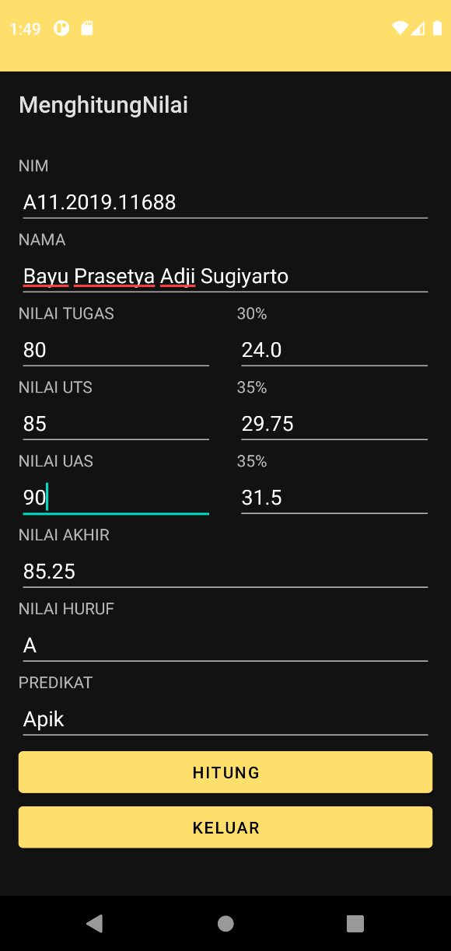

**Mainacvity.java**

package com.example.menghitungnilai;  
  
import androidx.appcompat.app.AppCompatActivity;  
  
import android.os.Bundle;  
import android.text.Editable;  
import android.text.TextWatcher;  
import android.view.View;  
import android.widget.EditText;  
  
public class MainActivity extends AppCompatActivity {  
 private EditText edtgs, eduts, eduas, edhuruf, edakhir, edpredikat, edptgs, edputs, edpuas;  
 private float ntgs, nptgs, nuts, nputs, nuas, npuas, nakhir;  
 private String predikat, huruf;  
  
 @Override  
 protected void onCreate(Bundle savedInstanceState) {  
 super.onCreate(savedInstanceState);  
 setContentView(R.layout.*activity_main*);  
  
 edtgs = (EditText) findViewById(R.id.*tugas*);  
 edptgs = (EditText) findViewById(R.id.*tugaspersen*);  
 eduts = (EditText) findViewById(R.id.*uts*);  
 edputs = (EditText) findViewById(R.id.*utspersen*);  
 eduas = (EditText) findViewById(R.id.*uas*);  
 edpuas = (EditText) findViewById(R.id.*uaspersen*);  
 edhuruf = (EditText) findViewById(R.id.*huruf*);  
 edakhir = (EditText) findViewById((R.id.*akhit*));  
 edpredikat = (EditText) findViewById(R.id.*predikat*);  
  
 *//nilaitugas* edtgs.addTextChangedListener(new TextWatcher() {  
 @Override  
 public void beforeTextChanged(CharSequence s, int start, int count, int after) {  
  
 }  
  
 @Override  
 public void onTextChanged(CharSequence s, int start, int before, int count) {  
  
 }  
  
 @Override  
 public void afterTextChanged(Editable s) {  
 if(edtgs.getText().toString().isEmpty()){  
 ntgs = 0;  
 }else{  
 ntgs = Float.*parseFloat*(edtgs.getText().toString());  
 }  
 nptgs = 0.3f * ntgs;  
 edptgs.setText(Float.*toString*(nptgs));  
  
 }  
 });  
  
 *//nilaiUts* eduts.addTextChangedListener(new TextWatcher() {  
 @Override  
 public void beforeTextChanged(CharSequence s, int start, int count, int after) {  
  
 }  
  
 @Override  
 public void onTextChanged(CharSequence s, int start, int before, int count) {  
  
 }  
  
 @Override  
 public void afterTextChanged(Editable s) {  
 if(eduts.getText().toString().isEmpty()){  
 nuts = 0;  
 }else{  
 nuts = Float.*parseFloat*(eduts.getText().toString());  
 }  
 nputs = 0.35f * nuts;  
 edputs.setText(Float.*toString*(nputs));  
  
 }  
 });  
  
 *//nilaiUas* eduas.addTextChangedListener(new TextWatcher() {  
 @Override  
 public void beforeTextChanged(CharSequence s, int start, int count, int after) {  
  
 }  
  
 @Override  
 public void onTextChanged(CharSequence s, int start, int before, int count) {  
  
 }  
  
 @Override  
 public void afterTextChanged(Editable s) {  
 if(eduas.getText().toString().isEmpty()){  
 nuas = 0;  
 }else{  
 nuas = Float.*parseFloat*(eduas.getText().toString());  
 }  
 npuas = 0.35f * nuas;  
 edpuas.setText(Float.*toString*(npuas));  
  
 }  
 });  
 }  
  
 *//tombolHitung* public void hitung(View view){  
 hitungAkhir();  
 edakhir.setText(Float.*toString*(nakhir));  
 edhuruf.setText(getHuruf(nakhir));  
 edpredikat.setText(getPredikat(huruf));  
 }  
  
 public String getHuruf(float nilai){  
 if (nilai >= 85){  
 huruf = "A";  
 }  
 else if (nilai >= 80){  
 huruf = "B";  
 }  
 else if (nilai >= 70){  
 huruf = "C";  
 }  
 else if (nilai >= 60){  
 huruf = "D";  
 }  
 else if (nilai >= 50){  
 huruf = "D";  
 }  
 else  
 huruf = "E";  
 return huruf;  
 }  
  
 public String getPredikat(String nHuruf){  
 switch (nHuruf){  
 case "A" :predikat = "Apik"; break;  
 case "AB" :predikat = "Apik"; break;  
 case "B" :predikat = "Apik"; break;  
 case "BC" :predikat = "Apik"; break;  
 case "C" :predikat = "Apik"; break;  
 case "D" :predikat = "Apik"; break;  
 default : predikat = " Elek";  
 }  
 return predikat;  
 }  
  
 private float hitungAkhir(){  
 nakhir = nptgs + npuas + nputs;  
 return nakhir;  
 }  
  
 *//tombolKeluar* public void keluar (View view){  
 finish();  
 }  
  
  
}

**activity_main.xml**

*<?*xml version="1.0" encoding="utf-8"*?>*<RelativeLayout xmlns:android="http://schemas.android.com/apk/res/android"  
 xmlns:app="http://schemas.android.com/apk/res-auto"  
 xmlns:tools="http://schemas.android.com/tools"  
 android:layout_width="match_parent"  
 android:layout_height="match_parent"  
 android:layout_marginVertical="16dp"  
 android:layout_marginHorizontal="16dp"  
 tools:context=".MainActivity"  
 android:orientation="vertical">  
  
 <TextView  
 android:id="@+id/txtnim"  
 android:layout_width="match_parent"  
 android:layout_height="wrap_content"  
 android:text="@string/txt_nim"  
 />  
  
 <EditText  
 android:id="@+id/nim"  
 android:layout_below="@+id/txtnim"  
 android:layout_width="match_parent"  
 android:layout_height="wrap_content"  
 />  
  
 <TextView  
 android:layout_below="@+id/nim"  
 android:id="@+id/txtnama"  
 android:layout_width="match_parent"  
 android:layout_height="wrap_content"  
 android:text="@string/txt_nama"  
 />  
  
 <EditText  
 android:layout_below="@+id/txtnama"  
 android:id="@+id/nama"  
 android:layout_width="match_parent"  
 android:layout_height="wrap_content"  
 />  
  
 <TextView  
 android:layout_below="@id/nama"  
 android:id="@+id/txttgs"  
 android:layout_width="170dp"  
 android:layout_height="wrap_content"  
 android:text="@string/txt_tugas"  
 />  
  
 <EditText  
 android:id="@+id/tugas"  
 android:layout_width="170dp"  
 android:layout_height="wrap_content"  
 android:layout_below="@+id/txttgs" />  
  
 <TextView  
 android:id="@+id/txtpersentgs"  
 android:layout_width="170dp"  
 android:layout_height="wrap_content"  
 android:layout_below="@id/nama"  
 android:layout_marginLeft="20dp"  
 android:layout_toRightOf="@+id/txttgs"  
 android:text="@string/txt_30" />  
  
 <EditText  
 android:layout_marginLeft="20dp"  
 android:layout_toRightOf="@+id/tugas"  
 android:id="@+id/tugaspersen"  
 android:layout_width="170dp"  
 android:layout_height="wrap_content"  
 android:layout_below="@+id/txttgs" />  
  
 <TextView  
 android:layout_below="@+id/tugas"  
 android:id="@+id/txtuts"  
 android:layout_width="170dp"  
 android:layout_height="wrap_content"  
 android:text="@string/txt_uts"  
 />  
  
 <EditText  
 android:layout_below="@+id/txtuts"  
 android:id="@+id/uts"  
 android:layout_width="170dp"  
 android:layout_height="wrap_content"  
 />  
  
 <TextView  
 android:layout_marginLeft="20dp"  
 android:layout_toRightOf="@+id/txtuts"  
 android:layout_below="@id/tugaspersen"  
 android:id="@+id/txtpersenuts"  
 android:layout_width="170dp"  
 android:layout_height="wrap_content"  
 android:text="@string/txt_35"  
 />  
  
 <EditText  
 android:layout_marginLeft="20dp"  
 android:layout_toRightOf="@+id/uts"  
 android:id="@+id/utspersen"  
 android:layout_width="170dp"  
 android:layout_height="wrap_content"  
 android:layout_below="@+id/txtpersenuts" />  
  
  
 <TextView  
 android:id="@+id/txtuas"  
 android:layout_below="@+id/uts"  
 android:layout_width="170dp"  
 android:layout_height="wrap_content"  
 android:text="@string/txt_uas"  
 />  
  
 <EditText  
 android:layout_below="@+id/txtuas"  
 android:id="@+id/uas"  
 android:layout_width="170dp"  
 android:layout_height="wrap_content"  
 />  
  
 <TextView  
 android:id="@+id/txtpersenuas"  
 android:layout_width="170dp"  
 android:layout_height="wrap_content"  
 android:layout_below="@id/utspersen"  
 android:layout_marginLeft="20dp"  
 android:layout_toRightOf="@+id/txtuas"  
 android:text="@string/txt_35" />  
  
 <EditText  
 android:layout_marginLeft="20dp"  
 android:layout_toRightOf="@+id/uas"  
 android:id="@+id/uaspersen"  
 android:layout_width="170dp"  
 android:layout_height="wrap_content"  
 android:layout_below="@+id/txtpersenuas" />  
  
 <TextView  
 android:layout_below="@+id/uas"  
 android:id="@+id/txtakhir"  
 android:layout_width="match_parent"  
 android:layout_height="wrap_content"  
 android:text="@string/txt_akhir"  
 />  
  
 <EditText  
 android:layout_below="@+id/txtakhir"  
 android:id="@+id/akhit"  
 android:layout_width="match_parent"  
 android:layout_height="wrap_content"  
 />  
  
 <TextView  
 android:layout_below="@+id/akhit"  
 android:id="@+id/txthuruf"  
 android:layout_width="match_parent"  
 android:layout_height="wrap_content"  
 android:text="@string/txt_huruf"  
 />  
  
 <EditText  
 android:layout_below="@+id/txthuruf"  
 android:id="@+id/huruf"  
 android:layout_width="match_parent"  
 android:layout_height="wrap_content"  
 />  
  
 <TextView  
 android:layout_below="@+id/huruf"  
 android:id="@+id/txtpred"  
 android:layout_width="match_parent"  
 android:layout_height="wrap_content"  
 android:text="@string/txt_predikat"  
 />  
  
 <EditText  
 android:layout_below="@+id/txtpred"  
 android:id="@+id/predikat"  
 android:layout_width="match_parent"  
 android:layout_height="wrap_content"  
 />  
  
 <Button  
 android:onClick="hitung"  
 android:id="@+id/hitungakhir"  
 android:layout_width="match_parent"  
 android:layout_height="wrap_content"  
 android:layout_below="@+id/predikat"  
 android:text="@string/btn_hitung" />  
  
 <Button  
 android:layout_below="@+id/hitungakhir"  
 android:id="@+id/keluar"  
 android:layout_width="match_parent"  
 android:layout_height="wrap_content"  
 android:text="@string/btn_keluar"  
 android:onClick="keluar"  
 />  
  
</RelativeLayout>

**String.xml**

<resources>  
 <string name="app_name">MenghitungNilai</string>  
 <string name="txt_nim">NIM</string>  
 <string name="txt_nama">NAMA</string>  
 <string name="txt_tugas">NILAI TUGAS</string>  
 <string name="txt_uts">NILAI UTS</string>  
 <string name="txt_uas">NILAI UAS</string>  
 <string name="btn_hitung">HITUNG</string>  
 <string name="txt_hasil">HASIL</string>  
 <string name="btn_keluar">KELUAR</string>  
 <string name="txt_akhir">NILAI AKHIR</string>  
 <string name="txt_huruf">NILAI HURUF</string>  
 <string name="txt_predikat">PREDIKAT</string>  
 <string name="txt_30">30%</string>  
 <string name="txt_35">35%</string>  
</resources>